BRAINSTORM & IDEATION PHASE
Date | 01.11.2025
Team ID | NM2025TMID02630
Project Name | Calculating Family Expenses Using service Now
Maximum Marks | 100 marks
Members | Role | Responsibilities
B.fajilafarith | Team lead
AL.Kathambari | Developer
S.Rudra | Tester
V.Jayasri | Documentor

To form a collaborative team , assign roles, and identify a real world problem that can be effectively

Team Collaboration:
- Discussion on key expense categories.
- Identifying ServiceNow modules needed.
- Planning data flow and roles for each members

PROBLEM STATEMENT
The problem statement is to create a system for calculating family expenses using ServiceNow by leveraging its financial management capabilities to track, categorize, and analyze household spending, and to generate reports and dashboards for informed financial decision-making.
This involves creating custom forms for data entry, automating the process, and using features like budget alerts and real-time analysis to provide insights into where money is being spent.

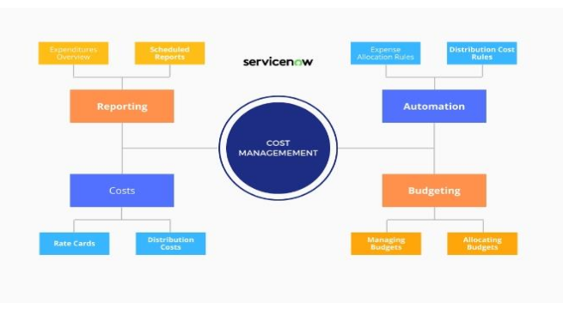

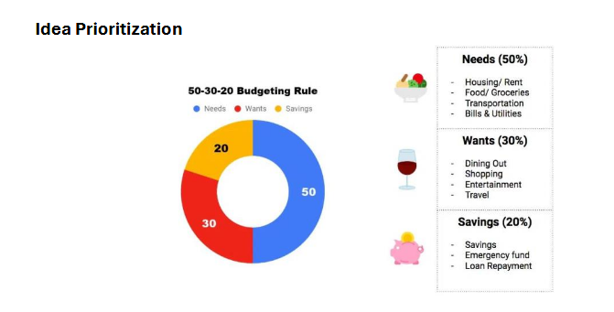
Conclusion:
Through this project, a ServiceNow-based Family Expense Tracker is proposed to simplify
budgeting and monthly spending management. The top-priority features include expense
entry, dashboard visualization, and budget alerts, which make tracking more accurate and
efficient. Future versions can include AI suggestions and external data integrations to
enhance performance.

